Drag and Drop in Selenium WebDriver

“Drag and Drop” is another mouse operation which means grabbing a WebElement and dropping it at another location. Selenium WebDriver provides Actions class to perform all mouse operations, and the method id dragAndDrop();

This operation can also we performed in another way. Let us understand both ways with an example:

Scenario:

1. Navigate to https://jqueryui.com/droppable/
2. There are two WebElements “Drag me to my target” and “Drop here”
3. Grab the first WebElement, move it other and drop there.

Refer below image:

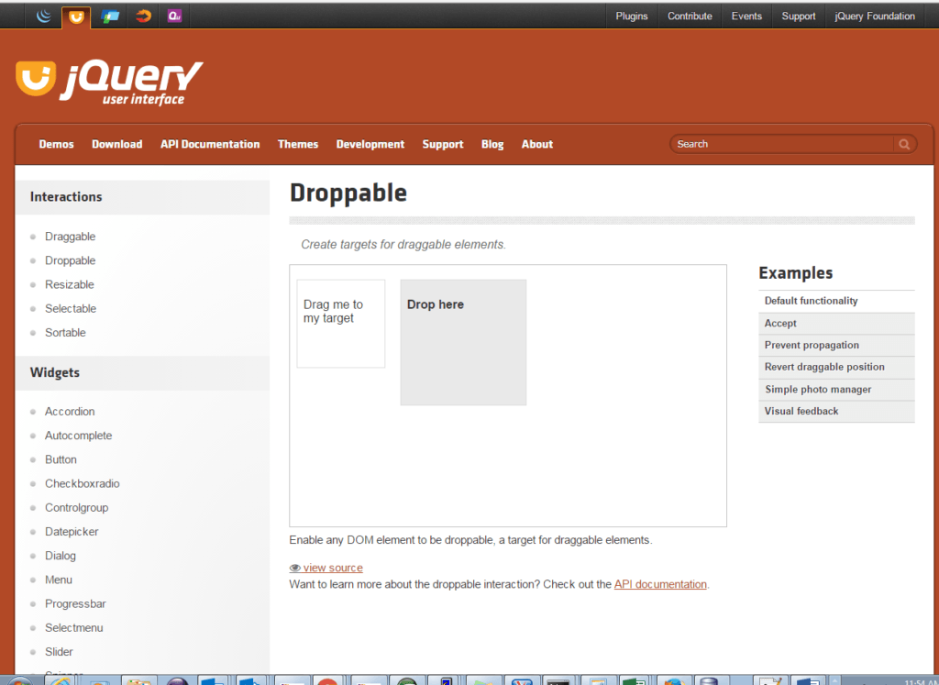

public class DragAndDrop {

public static void main(String[] args) {

ChromeDriver Driver;

System.setProperty("webdriver.chrome.driver",

"C:\\workspace\\libs\\chromedriver.exe");

Driver = new ChromeDriver();

//Maximizing the browser

Driver.manage().window().maximize();

//To delete(by-pass) all the cookies from browser

Driver.manage().deleteAllCookies();

Driver.manage().timeouts().pageLoadTimeout(90, TimeUnit.SECONDS);

Driver.manage().timeouts().implicitlyWait(20, TimeUnit.SECONDS);

String url = "http://jqueryui.com/droppable/";

Driver.get(url);

WebElement frame = Driver.findElement(By.className("demo-frame"));

Driver.switchTo().frame(frame);

WebElement source = Driver.findElement(By.id("draggable"));

WebElement target = Driver.findElement(By.id("droppable"));

Actions action = new Actions(Driver);

action.dragAndDrop(source, target).build().perform();

}

}